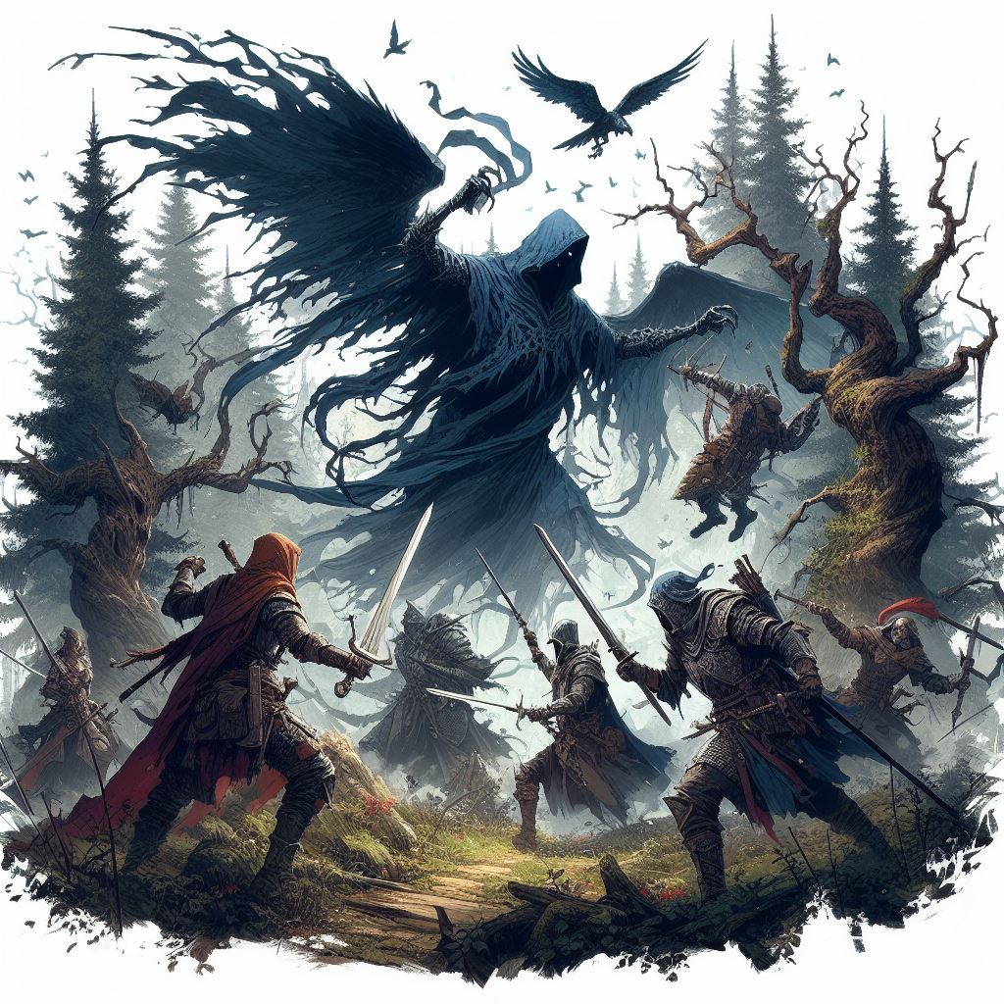







# E:\Work\GitHub\Call of Heroes Design\StarterAdventure\UI\Title Underline.pngTitle UnderlineIntroduction

Welcome, Game Master! This book is for your eyes only. It contains the QuestGuard starter campaign Whispervale with instructions on how to play and organize this story for your players.

If you are not a Game Master, close this book immediately.

## Who Is This For

This book is intended for beginner Game Master and players who have never played QuestGuard. It was made to be as easy as possible to run.

If you have never been a Game Master, now is your chance.

## What To Expect

Whispervale follows a group of 3 to 5 players, on an adventure that will last (on estimate) 5 to 10 game sessions, depending on the group’s pace and duration of sessions.

As a Game Master, you are **not required to read this book in advance**. Whispervale was made to be **read at a glance** - it requires minimal preparation. However, please read everything up until Chapter 1

before you begin, to learn how to use this book. Once you get to Chapter 1, simply let the book guide you.

The book contains many read-aloud sections, and flows top-to-bottom, left-to-right and will guide you through everything you need to say and do.

This campaign also teaches the players the basic rules of QuestGuard in the first sessions.

It also teaches you, the Game Master, the rules for QuestGuard from a Game Master’s perspective.

## Your Responsibility

As a Game Master, you will be the narrator and referee of the game. You present situations, and players will try to do things in those situations. A lot of the times, a **Check** is required (a roll of a die) to determine if the player succeeds in their action.

You will be responsible for reading passages out loud for your players, roleplaying as non-player characters (e.g. speaking in the voice of another character or conveying what they are saying), controlling the monsters in fights (e.g. rolling dice for them) and, usually, making sure every player gets their time in the spotlight and is having a good time.

# E:\Work\GitHub\Call of Heroes Design\StarterAdventure\UI\Title Underline.pngTitle UnderlineHow to Read It

This section explains how to read the book and interpret various elements.

## Read-Alouds

When you encounter text with a tan background like this one, read it out loud for the players.



*This is some sample text.*

*It’s just an example.*

*Whenever you see this in the section you’re in,*

*read it out loud.*

There will be a lot of these and they will narrate not just story elements, but also rules.

As a Game Master, **a lot of the information you have is from read-alouds**. These read-alouds will serve as information for both you and the players.

## NPC’s - When In Doubt…

When in doubt of what an NPC would say, resort to them saying *“I don’t know” or a similar reply*.

Don’t worry - you will get good information on NPC’s that is easily readable at a glance, without requiring preparation. Feel free to paraphrase NPC dialogue lines.

NPC Replies

In some sections, NPC’s (non-player characters from the story) will have potential replies to say. Here is an example for a random peasant players encounter:



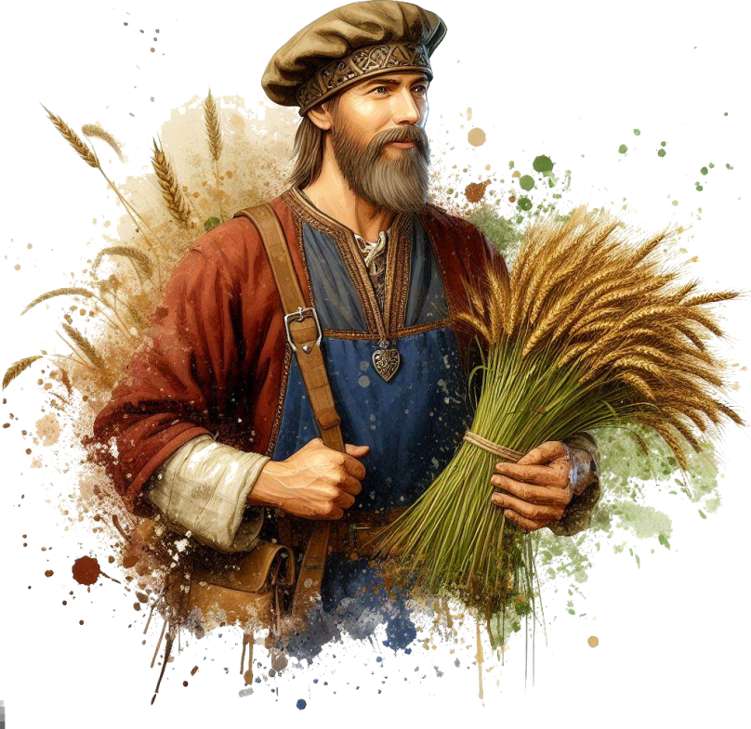***“****Welcome to our village, adventurers!”*

***“****You look hungry. Head over to the tavern, they*

*serve good food!”*

***…****I did see* ***a strange man******in the******woods*** *last night!*

*…No, I never* ***stole*** *anything in my life! [lie,*

*he stole coins from the church donation box]*

You will see read-alouds with NPC replies.

The first few lines, in quotes, are dialogue lines meant to be **said directly** by the NPC (e.g. casually mentioning them in a conversation). For example, say the first dialogue line, wait for the players’ response, and if you see fit, say the next dialogue line. Rinse and repeat.

Lines starting with **…** are meant to be **only answers to questions** players ask, and should not be given without being asked specifically about the subject.

**Bold** phrases or words are emphasized to easily come into your view in case players ask about it.

If an NPC has no dialogue lines about a subject, then they don’t know about it.

## Suspicion (0 to 20)

Each NPC has a secret **Suspicion** level from 0 (is completely friendly and trusts the players) to 20 (will not even talk to the players or is outright hostile).

Whenever the players try to persuade an NPC and the NPC isn’t sure of what to do, have the players roll a Charisma Check at least equal to the NPC’s Suspicion.

On a successful Check, decrease **Suspicion** by 1. Otherwise increase it by 1.

If players say something insulting or fitting to the conversation, increase or reduce Suspicion by 1.

Keep track of the NPC’s **Suspicion**.

Depending on how mild or crazy the player’s idea is, secretly give a +5 or -5 to their check.

Decreasing **Suspicion** will unlock certain dialogue lines.

# E:\Work\GitHub\Call of Heroes Design\StarterAdventure\UI\Title Underline.pngTitle UnderlineLocations & Sections

The book’s chapters function as Locations.

Each “chapter” is a separate Location that contains read-alouds, artwork, scenarios, etc.

Here is an example:

# E:\Work\GitHub\Call of Heroes Design\StarterAdventure\UI\Title Underline.pngTitle UnderlineThe Windmill



*As you ascend the winding cobblestone path, you*

*approach a decrepit fence. Pushing through the*

*rotting wood, you arrive at the entrance of an old*

*wooden windmill, now reclaimed by nature,*

*overgrown with vegetation. The air carries a*

*musty scent, tinged with the earthly smell of*

*decaying wood, hinting that has been standing for*

*centuries, untouched by human hands in many*

*decades.*

By the way, if a part of text is covered in a dotted-line box, then it’s just an *aside* from the main text.

## If Sections…

Some sections are titled “If…”.

Only read these sections if the title applies. If not, skip them and continue.

For example:

## If There Are 5 Players…

*As* ***[player 5]*** *enters the windmill, the floorboards*

*crack open and* ***[player 5]*** *falls through*

*into a stone basement.*

## Returning to Locations

If players return to a location or NPC, don’t repeat the same read-alouds or dialogue lines (unless they specifically ask for it).

Random Encounters

There exists a list of random possible encounters players can have while exploring the forest.

Event locations in the random encounters can be placed anywhere on the map.

If they are (almost) full Health and Mana, give them a **combat encounter**. If not, give them a **non-combat encounter**. Pick randomly or whichever sounds interesting.

Some encounters can be resolved through either combat or roleplay and negotiation.

All random encounters are connected to the main story.

If players ask for extra work, have an NPC send them to do a specific random encounter (e.g. a guard sends them to investigate smoke coming from the forest - this would be the **Forest Smoke** encounter). Award missions with a total of 50 to 250 gold, randomly or depending on how hard you think it will be for them.

All random encounters are listed at the **beginning of the adventure**.

Every random encounter is detailed as a separate **Location** **at the end of the book**.

## Props

The campaign contains paper props, such as a map, secret letters, etc. Only give these out when instructed by the book. Keep them secret until the book tells you to show it to the players.

Sometimes the book will tell you to show the players a picture of something. You can use a phone, TV screen or a laptop to show them the picture, which you will find in the Digital Appendix.

# E:\Work\GitHub\Call of Heroes Design\StarterAdventure\UI\Title Underline.pngTitle UnderlineCombats

You will have to control monsters in combats. The book will tell you how to run each monster.

## Running Combats

When running combats, try to spread the enemies as evenly as possible on the players (e.g. if you have 4 enemies and 4 players, each enemy should attack a different player). Dying in the first round is no fun!

…unless players want to spread the damage differently (e.g. if the knight wants to front-line and take the damage instead of the mage in the back).

To find the **stats of a monster**, check the **Appendix**.

## Battle Maps

Each combat encounter comes with a battle map, which you can find in the Digital Appendix. If you’re playing online, you can use the exact map. If you’re playing on a table with pen and paper, you can draw a sketch of what the battle map looks like.

You can skip some of the details when drawing (e.g. trees, rocks, etc) unless it specifically says that thing is important to the map.

This is what a battle map will look like **for you, in the book only**. Do **not** draw text on the map! Any annotations on the map are for your eyes only! The digital maps in the Digital Appendix don’t contain the annotations.

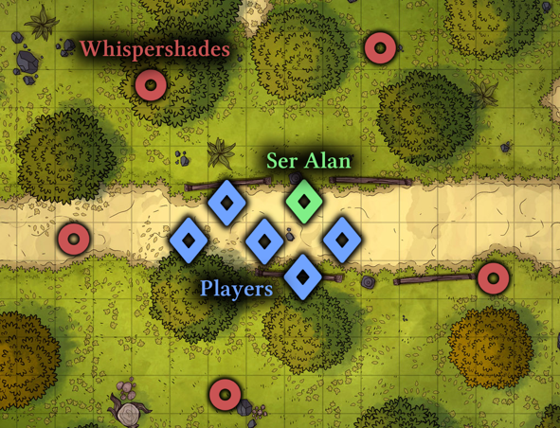

The map annotations are self-explanatory. Diamonds represent player or allied Units (creatures). Blue for players, green for allies, yellow for neutral. Circles represent enemies. Red for hostile, orange for possibly hostile

# E:\Work\GitHub\Call of Heroes Design\StarterAdventure\UI\Title Underline.pngTitle UnderlineStory Breakdown

The story begins as soon as all the players are ready and have their characters finished.

This adventure follows the player characters exploring the gloomy town of Whispervale and fighting the forces of the vampire lord Sedrik, while struggling to rid themselves of a strange curse.

It starts with the player characters escorting a priest to Whispervale. They are soon ambushed by a group of black ghosts, which they will have to defeat. Regardless of their victory, the ghosts curse the players.

The players will eventually get to Whispervale

and the story will unfold, revealing the secrets of lord Sedrik and of the inhabitants of Whispervale.

When you want to present the idea of

Whispervale to your players, read the following

out loud:



*Whispervale: a town at the edge of civilization*

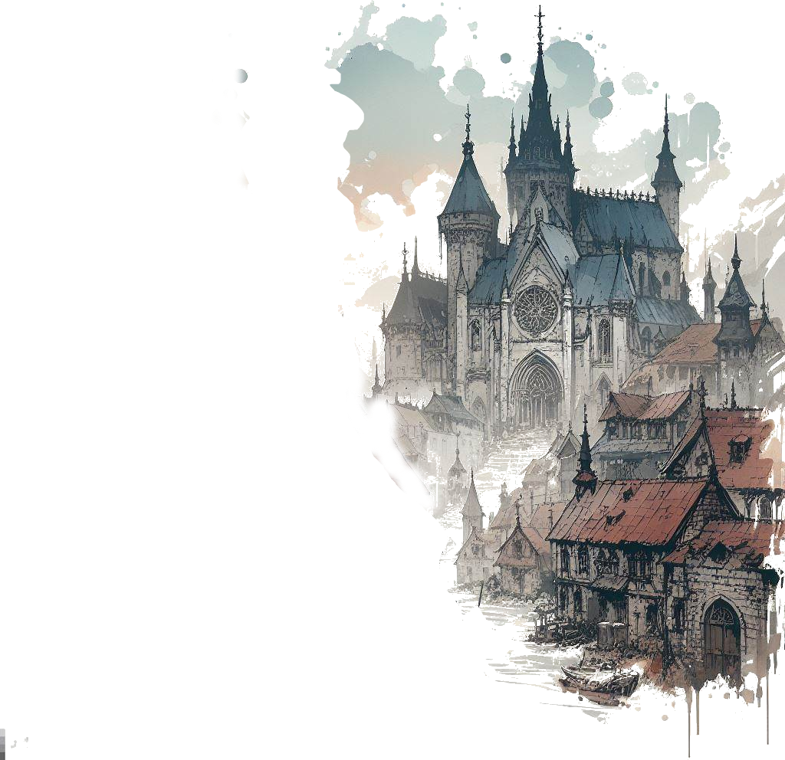*where you will discover a tapestry of secrets*

*woven into the very fabric of this town’s history.*

*Are the townsfolk merely succumbing to*

*paranoia, or does a palpable darkness truly lurk*

*beneath the surface?*

*These secrets are for* ***you*** *to unravel.*

*You will be playing the roles of fresh adventurers*

*exploring the small town of Whispervale and its*

*surrounding woods, rivers and meadows.*

*You will battle wicked monsters, interact with*

*the inhabitants of the town and piece*

*together clues to solve the overarching mystery*

*of Whispervale.*

*So ready your sword, find your notes and your map*

*markers, plan out accordingly, and immerse*

*yourselves in the story of Whispervale.*

You can give the players the extra information that they will play Level 1 characters and the theme, while not horror, has a tent of dark fantasy. There are (hopefully) no elements that would make the players uncomfortable:

There is no depicted gore or disturbing visual imagery in the book, not shown, nor told. There are no disturbing visuals and no topics that would be considered “taboo” in the real society.

However, the story can be gloomy, have the characters make morally gray choices, and contain potentially unsettling monsters (such as undead or spiders) or unusually looking people.

On the upside, the story provides props: maps, letters, clues and pictures of many locations and characters.

## Player Backstories

Player backstories won’t really matter, unless you choose to improvise them into the story, though that can be difficult. Tell them to come up with adventurer characters. with simple backgrounds, that would accept to be paid to escort a priest to another town - Whispervale.

With their permission, you will give them an extra reason to go to Whispervale (in the **Road to Whispervale** Location).

## Story Explained

The story revolves around 2 characters: Mortessa and Sedrik. The following is information that players will piece together throughout the campaign:

A couple hundred years ago, Lord Sedrik was a noble living in a mansion in Whispervale. He wanted the love of a mage, Mortessa, who was secretly practicing black magic. Lord Sedrik found out about it. She claimed she could make both of them immortal. Lord Sedrik wanted no such thing - black magic was unnatural.

The black magic practices were creating deep conflict in their relationship, as well as Mortessa’s secret rituals and dubious morality.

Mortessa held her opinion: “I can show you! I will show you!” she said. She cast a spell on Lord Sedrik and turned him into an immortal vampire through 1000 curse marks on his body, living him devoid of any bodily sensation and feeling depersonalized, like an empty vessel. The ritual unfortunately used several members of Sedrik’s family and people living in the mansion as tribute, and they all died.

Sedrik was enraged at the sight of the dead people and him having become an abomination. He attacked Mortessa and swore to hunt her to death.

She escaped and fled, never to be seen again.

Lord Sedrik now resides somewhere in his lair. He wants to rid himself of the curses of vampirism and kill Mortessa in justice and revenge.

Mortessa is keeping up an aura of life-draining, perpetually draining life from all inhabitants of Whispervale to keep herself immortal. However, this aura is also protecting the citizens from being affected by Lord Sedrik’s special device (and against all blood magic artifacts and spells).

She also knows Sedrik will eventually come after her, so she has been raising an army of undead to both protect herself, and try to kill him before he kills her.

Sedrik can remove his curses by transferring them one by one to other people, though most don’t survive the curse marks. After more than 200 years of study, he finally discovered there is a way to remove the curse en masse - he is creating a device to transfer curses to a large part of Whispervale’s population. The device isn’t working due to Mortessa’s magic protecting (and draining) the citizens.

Luckily, a cult has formed around Sedrik’s curse marks and he plans to use the cult to get to Mortessa and remove some of the curse marks. Sedrik has also learned to use his vampiric abilities to subjugate and mind-control Mortessa’s stray undead in his favor.

Both Mortessa and Sedrik are villains in this story and seek to fulfil their goals by any means necessary.

Neither Mortessa nor Sedrik knows where the other is hiding.

## Players’ Progression

Players start escorting Ser Alan, a retired paladin, to Whispervale, when they get ambushed by black ghosts, inflicting players with 1 of the 1000 curses of Sedrik.

A druid named Riven can cure their curse with a magical lamp they will need to retrieve for him.

Players will also investigate Sedrik’s old mansion, where a different monster now resides. They will meet Sedrik face-to-face and find clues about where Mortessa lives.

They will go after Mortessa and end her life draining, and, finally, they will find Sedrik’s hiding place and deal with him.

Of course, this is not as straightforward as it seems - players will have to talk to NPC’s, survive fights with undead, solve puzzles and mysteries and make their way through.

Whispervale also contains a lot of side quests, which are completely optional but are all tied to the main mission. Players can do these side quests to reveal more of the story (or more sides of the story) and for extra items, experience and gold.



# E:\Work\GitHub\Call of Heroes Design\StarterAdventure\UI\Title Underline.pngTitle UnderlineSpecial Rules

All of these are rules that you should only tell the players when the time is appropriate or they discover that on their own.

## Leveling Up

Players will Level Up after every second completed Quest. The book will tell you when a “Quest complete!” happens. Keep track of the Quests completed (or tell the players to keep track).

## Night Regeneration

After combat at night, Player Characters with the Curse Mark regenerate an extra +2 Health.

## Curse - Preventing Leaving

The farther away someone with a Curse Mark strays from Whispervale, the more weakened they become. Someone cursed will feint before they reach another town.

## Mortessa’s Aura

While Mortessa is alive, special Whispervale blood spells don’t work on Units that are not affected by the Curse Mark (players will find such spells later).

Whenever a player tries to use a blood magic artifact or spell on someone without a Curse Mark, tell them it simply fizzles out and nothing happens, as if the magic against that target is being blocked by something.

## Shaman Class Special Rules

Since the Witch Doctor (Shaman) specialization uses blood magic, their powers won’t work unless they have the Curse Mark, until Mortessa dies.

If the players want to remove the Curse Mark later on, make sure you hint to the Witch Doctor player that their powers will fail from then on.

## Death

If one player dies, a citizen can replace them, having the same Level and they can play as them. Choose one from: Ser Alan (Paladin), Periwinkle the Merchant (rich Mage), Boris the Blacksmith (Warrior with missing leg), Sylvaine the Bard (Rogue).

You can find more details about these characters in the appendix.

## Party Wipe

If the whole party is wiped in a combat and they have the **Felinar of Passing**, the Felinar explodes and they are transported to the church basement in town. They lose the **Felinar of Passing**.

If they don’t have it, the game is over.

While some encounters are more difficult, none are meant to kill the players. Feel free to otherwise improvise a way to let players survive.

## What Players Should Know

From the start, the players should know the following:



*Before we begin, here are some things you should*

*know: you should track your own Health, Mana and*

*resources, since they will keep changing.*

*It will also be very useful to take notes, as there*

*could be information you need for later.*

*You will be fighting monsters, solving puzzles and*

*talking to various characters throughout the*

*adventure.*

*Note that every non-player character may like or*

*dislike you, and everything you say to them will*

*influence how they react, what they do and how*

*much they trust you.*

*As an ethical guideline, try not to split the party,*

*interrupt people while talking, and remember that*

*the Game Master always has the last word.*

*Most importantly, have fun and make sure everyone*

*else is having fun, too!*

# E:\Work\GitHub\Call of Heroes Design\StarterAdventure\UI\Title Underline.pngTitle UnderlineRandom Encounters

## Angry Peasants

**Type**: Combat / Roleplay

**Recommended Party Level**: 1

Players are attacked by a group of angry peasants set on witch-hunting people with curse marks or who use black magic.

## Forest Smoke

**Type**: Exploration + Roleplay

**Recommended Party Level**: 1 (or any)

Players see smoke coming from the forest. Upon investigating, they find an injured villager studying blood magic.

## Ruins of Old Temple

**Type**: Combat + Puzzle

**Recommended Party Level**: 1

The ruins of an old small temple, now used by goblins as shelter. A runes puzzle reveals treasure and lore.

## Convoy of Undead

**Type**: Combat / Stealth

**Recommended Party Level**: 2

Players stumble upon a convoy of zombies and a carriage being pulled somewhere unknown, through the forest.

## Dragon in the Sky

**Type**: Exploration

**Recommended Party Level**: 2

Players witness a black dragon flying through the skies.

## Mysterious Cultists

**Type**: Combat / Roleplay

**Recommended Party Level**: 2

Players are approached by mysterious cultists that want to bargain (or fight) for players’ artifacts. They can provide lore or trade

## Town Vampire Hunt

**Type**: Combat + Roleplay

**Recommended Party Level**: 2

In town, players witness a group of villagers set on finding a vampire hiding in town.

# E:\Work\GitHub\Call of Heroes Design\StarterAdventure\UI\Title Underline.pngTitle UnderlineBefore Starting…

Before starting, some players get private information. They are free to keep the information a secret or reveal it whenever they like.

## If there is a Druid player…

*You’ve heard rumors of a certain druid living on*

*the outskirts of Whispervale, isolated from*

*society. Word goes around that this druid,* ***Riven****,*

*can cure both poisons, minor illnesses and even*

*more potent curses.*

*Naturally, you felt inclined to find out more, and*

*perhaps Riven could teach you a thing or two!*

*Feel free to share the information with the others*

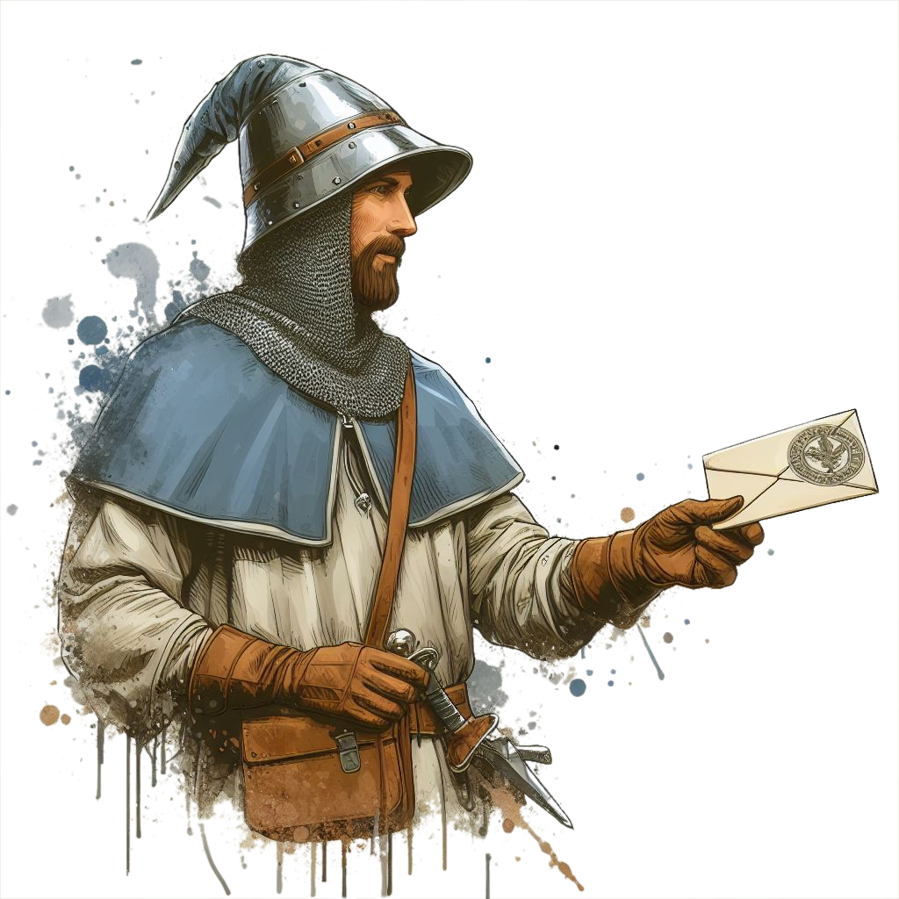*when you see fit, or keep it secret.*

## Gradient TopIf there is a Rogue player…

*You will be paid to escort a priest to a town called*

*Whispervale, together with the other adventurers.*

*However, you secretly have another reason to visit*

*Whispervale…*

*Your sources say there is an* ***abandoned mansion***

***full of riches*** *near Whispervale. Old rich folk hide*

*their treasures in armchair stuffing and under*

*fake cabinet bottoms - piece of cake, you know*

*where to look! Grab it while they’re not looking!*

## If there is a Shaman player…

*You will be paid to escort a priest to a town called*

*Whispervale, together with the other adventurers.*

*However, you secretly have an extra reason to visit*

*Whispervale…*

*You sense breaches in reality that connect the*

*mortal realm to a parallel spirit dimension called*

*the* ***Shadowrealm****… as if someone is using the*

*Shadowrealm to go in and out, and appear at*

*different locations.*

*Naturally, you felt inclined to investigate.*

*Feel free to share the information with the others*

*when you see fit, or keep it secret.*

## If there is a Warlock player…

*You will be paid to escort a priest to a town called*

*Whispervale, together with the other adventurers.*

*However, you secretly have an extra reason to visit*

*Whispervale…*

*You’ve heard of a certain magical*

*artifact called the* ***Felinar of***

***Passage****. This item would allow*

*the user to create passages*

*through a different realm and quickly travel*

*between locations. A fitting power for your*

*ilk!*

*Feel free to share the information with the others*

*when you see fit, or keep it secret.*

# Gradient TopGradient Top

# E:\Work\GitHub\Call of Heroes Design\StarterAdventure\UI\Title Underline.pngTitle UnderlineRoad to Whispervale



*Not long ago, you arrived at Outwell, a tiny*

*village huddled on the outskirts of the realm,*

*marking your final stop before setting off to*

***Whispervale****, your next destination.*

*The days of early autumn spent on the road have*

*so far been uneventful. As you linger at the edge of*

*the town this cold morning, you await for your*

*employer and new travelling companion: a retired*

*paladin by the name of Ser Alan.*

*You have been tasked with protecting Ser Alan*

*on the 1-and-a-half-day road to the town of*

*Whispervale to check on his old colleague who*

*hasn’t been responding to his letters. You picked*

*up this job from a simple questboard. The man was*

*promising to pay 100 gold each for seeing that he*

*reaches Whispervale safe and sound.*

## If there is a Paladin or Cleric player…

*Of course, to you* ***[Paladin or Cleric]****, Ser Alan is*

*no mere paladin - in your religious studies, you’ve*

*come to know Ser Alan personally.*

*While his fighting days are long gone, he is a*

*trusted member of the small branch of your*

*religion. [if their religion is similar to Christianity,*

*ask them to give a brief description].*

*You trained under him for a while, listened to his*

*old stories and, whenever you had doubts about*

*your path in life, Ser Alan was always there to*

*provide his wisdom and guidance, and it is now*

*your turn to give a helping hand.*

*That’s why he chose you specifically for this mission,*

*and told you in person the day before to join the*

*others on the road. You will, of course, be paid, too.*

*Ser Alan always keeps his word.*



*As you keep your eyes peeled for the man, a*

*figure emerges from around a nearby building.*

*He walks slowly on the cobblestone road towards*

*you, dressed in modest tan and blue clothes, and*

*carrying an old arming sword on his waist.*

*He looks to be a human in his late 60’s, wearing a*

*thick gray beard, and unkempt hair.*

*He approaches cautiously, and, with a subtle smile*

*on his face, he raises his hand and greets you:*

*Ser Alan Johnson (Ser Alan.png)*

**Base Suspicion**: 5

Calm, religious and calculate in his words. Serious but can appreciate humor.

Feel free to show the players a *picture of Ser Alan*.



*“Greetings! Apologies for the wait, I did not expect*

*you to be here early!*

*I am Ser Alan, the man you will be escorting*

*to Whispervale. You look like capable folk, I hope*

*we will get to know each-other better on the*

*journey ahead!*

*How should I call you, by the way? Feel free to*

*introduce yourselves… to me and to your new*

*companions if you haven’t exchanged pleasantries*

*yet!”.*

Ask each player to introduce their character to you and to the other players - what is their name, class and personality?

When finished, continue to the next page to Ser Alan’s dialogue lines.

## Continuing…

After the players introduce themselves, continue the narration.



*Having met your new teammates, you set off to*

*Whispervale. Unfortunately there are no carts or*

*carriages going to Whispervale for easier travel and*

*the journey will take a day and a half, at normal*

*pace. It is an isolated settlement down a forest path,*

*not part of the same realm as the towns you’ve*

*been to. Due to neglect, fear of road bandits, or*

*ignorance, not many people travel to Whispervale.*

*You tread along the forest road, leaves cracking*

*beneath your feet. The air is crisp and clear,*

*carrying the scent of moss and canopy trees. It is*

*still daylight, and you still have a few hours to go*

*before you need to camp for the night.*

## Father Alan Road Dialogue

Father Alan will engage in dialogue with the players while walking, to pass time. If they don’t engage,

feel free to directly say some of the **…** lines.



*“This friend of mine, Wilfred, is the town priest in*

*Whispervale… at least, I hope he still is.”*

*“We used to study the crafts of the church together,*

*and we usually exchange letters every year. This*

*year, however, I got no response… from anyone.*

*Not from his apprentice, nor from anyone in town.*

*I sent multiple letters, but… I fear something may*

*have happened to him or his church.”*

*“I assume it is possible that my letters never made*

*it to him… or his letters never made it to me. If*

*there are bandits or wild animals threatening*

*people on the roads, we’d best take care of them.”*

*...I’ve been to* ***Whispervale*** *before. It’s a nice, quiet*

*town. Haven’t been there in years, though.*

*...****Dangers****? Bandits, goblins, wild bears… most*

*people would be afraid to travel this route, let*

*alone camp the night on the road.*

*…****Townsfolk****? I just visited the church and inn…*

*…****Map****? I don’t have a map of the area, but I have a*

*map of Whispervale! Here… [give the players the*

*Whispervale Town Map]*

*…****Religion****?*

*[if there is a Paladin or Cleric player] Our branch is*

*founded on our god. We give thanks for the light of*

*day and for our healing powers and guidance, and*

*we pray the light guide us in our darkest times. Your*

*friend here can give more details, if they wish!*

*[if there is* ***no*** *Paladin or Cleric player] I found*

*sanctuary in the embrace of the Church of Solais.*

*We offer praises for the light of day and the divine*

*gifts of holy magic bestowed upon us. We pray that*

*Solais show us the righteous path in life and light*

*our way in our darkest moments.*

*…****Combat****? Oh, the sword I carry hasn’t been used in*

*years! If I could still handle myself in combat, I*

*wouldn’t need protection on the road. But my days*

*of fighting are long gone, and my divine spell casting*

*skills are rusty.*

*…****My home****? I live a couple of villages away. I don’t*

*travel much nowadays.*

*...****Ser****? I used to be a knight of the church, a crusader*

*if you wish. The title stuck; the benefits - not so*

*much. The older I got, the less I was needed.*

## Continuing…

After Ser Alan is done conversing with players…

After a long day of traveling, the sun starts dipping

low on the horizon,a nd you realize that nightfall

is approaching.

the night was upon you and you setup camp on the side of the road, in a nearby alcove. The day on the road was mild - nothing gave you any trouble, and step by step you’re getting to Whispervale.

It is a starry night with a clear sky,



*After a day’s worth of traveling, the sun starts*

*dipping low on the horizon, and you realize that*

*nightfall is approaching.*

*“It is starting to get dark” says Ser Alan.*

*“Does any of you know how to make a fire?”*

*[Speaking as the GM] I would everyone to make*

*an Intelligence Check: roll a 12-sided die and add*

*your Character’s Intelligence Stat number to the*

*result.*

Everyone who got at least a 5 knows how to make a fire. Tell them that.



*Ser Alan gives a nod of approval.*

*“Great!” he says. “It will keep us warm through the*

*night. I know an alcove nearby where we can*

*safely camp. We can setup our tent there and…”*

*Ser Alan pauses for a moment, looking from side*

*to side.*

*“Something feels wrong… do you feel that?”*

*The players will soon be ambushed by Whispershades - undead ghosts.*

Ask the player(s) with the highest Sense to make a Sense Check.

If any gets at least 8, tell them this:



*You feel an odd chill in the air, and a slight shiver*

*down your spine. The surroundings are strangely*

*quiet… no sound coming from the woods.*

If not:



*You struggle to understand what Ser Alan is*

*sensing, but surely he senses* ***something is wrong.***

Wait for the players to react.

Whatever they do or say, continue without letting too much time pass:



*As you are [doing/talking], a smoky shadow*

*materializes, growing and morphing into a bizarre*

*creature - a black phantom with razor-sharp claws,*

*mere meters away!*

*You soon notice several more such creatures*

*appearing around your group out of thin air!*

*Emitting an eerie shriek as it hovers just above the*

*ground, the apparition flies towards you with*

*menacing intent, claws poised to strike! [show*

*the players a picture of a Whispershade]*

*[As GM] Everyone roll for Initiative!*

*Roll a 12-sided die and add the Initiative number*

*from your character sheet.*

*You will now begin combat, and the numbers you*

*roll will determine the order in which you take turns.*

Write down the number of each player in descending order, and the number of the number 7 in there too.

All Whispershades have an initiative of 7 and don’t roll.

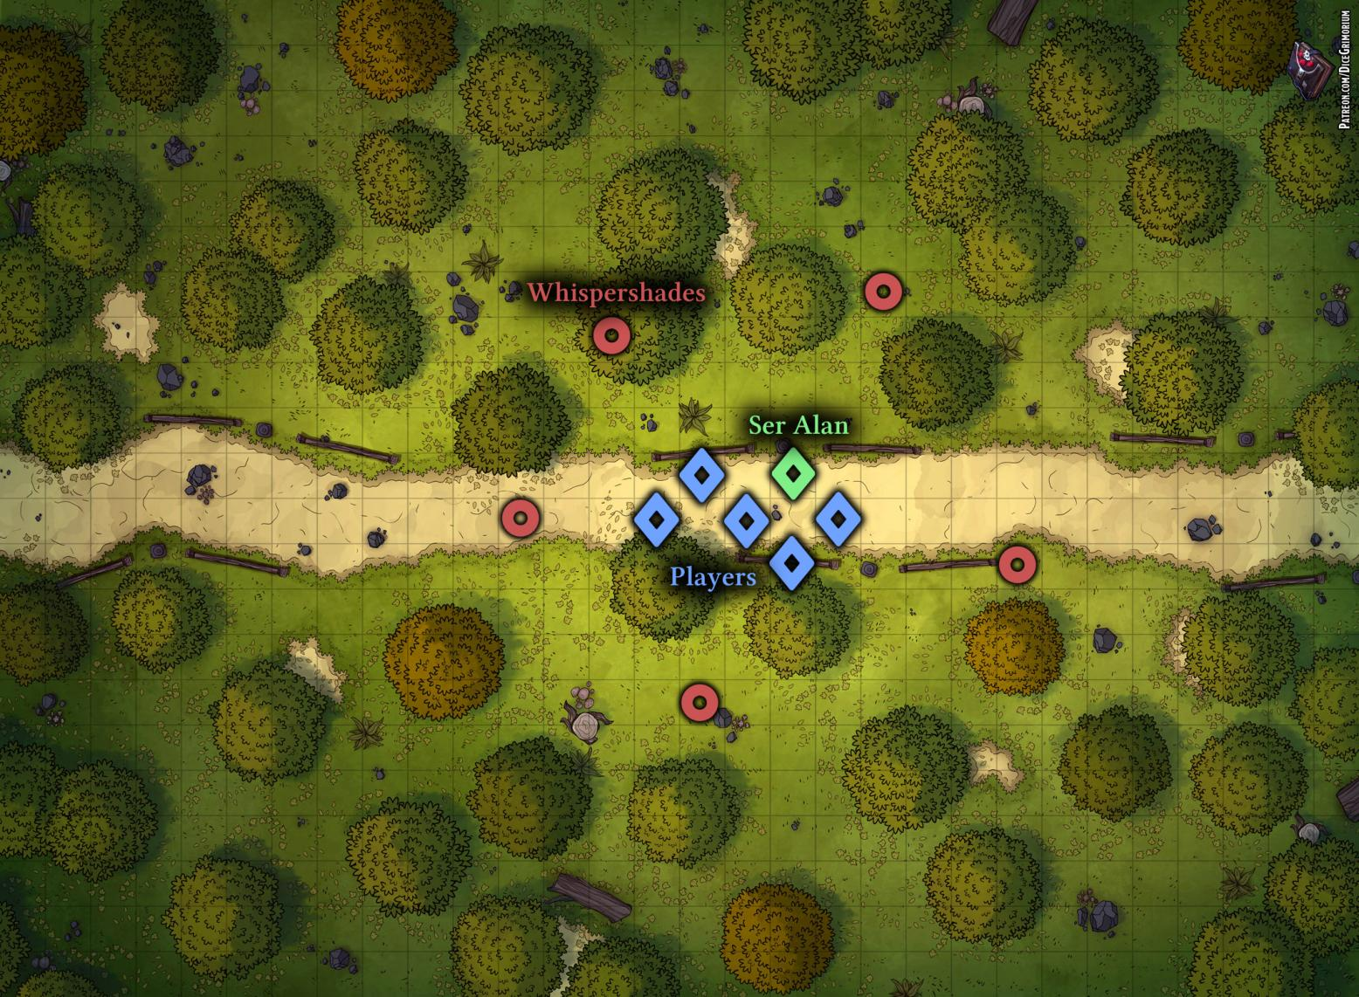

*Road to Whispervale Whispershades.png*

## Whispershade Combat

Find the Whispershade monster and the Road to Whispervale Whispershades combat map in the Appendix and start the combat!

Each player should be attacked by 1 Whispershade.

Ser Alan has 30 Health. He has his sword in hand and once per round, at the end of the round, he will attack a Whispershade for 1d6 damage.



*[As GM] As a reminder, here is what you can do:*

*On your turn, you can move up to your*

*speed, and you have one Action, which you can split*

*into 2 Half-Actions.*

*Attacks with 2-handed weapons take 1 Action, and*

*attacks with 1-handed weapons take a Half-Action.*



*If you have special Abilities, each tells you*

*exactly what it requires, what it costs, and so on.*

*Keep track of your Health and Mana.*

*When the combat is over, you will regenerate some*

*of your Health. Now - what do you do?*

When combat is over, proceed to the next page.

## Whispershade Combat

*As you land a decisive blow against the last ghost,*

*you pause to catch your breath and a strange*

*thought washes over you.*

Ask every player to describe where they got hit by a Whispershade (e.g. shoulder, leg, etc). Paladins and Clerics are unaffected.

Everyone heals for an amount equal to their Health Regeneration. Continuing…



*You notice an unusual change in your body.*

*Glancing down at your* ***[body parts]****, you’re taken*

*aback to discover a curious blackened scar where*

*the Whispershade’s claw had struck.*

*[Show the players a picture of the Curse Mark]*

*There is no pain - quite the opposite. As you touch*

*it, there is absolutely no sensation. As if that body*

*part no longer exists at all, yet you can still move it.*

*Curse Mark.png*

The players may or may not share the information with Ser Alan (who is unaffected due to being a Paladin).

On a **Check** at least 10, players can tell this is cursed.

At least 15 - they can tell it is a potent curse that is very hard to remove and it is a form of blood curse, tying the curse bearer to another certain place or creature.

Proceed to his lines of dialogue on the right.

*...****Strange black mark****? I’ve never seen this before!*

*By the gods, that looks cursed! (Ser Alan analyzes*

*the Curse Mark and shakes his head) This thing…*

*it is no mere curse. When we’re in town, I will talk*

*to my friend and look for a remedy in the church, or*

*for a special ritual to remove this… but I’ll be frank,*

*I am genuinely puzzled.*

*…****Me being cursed****? Paladins are immune to this*

*kind of magic - we are warded by the light.*

*…****What to do****? Whispervale is a few hours away.*

*We could go right now if you think it’s that urgent!*

*But it’s already gotten dark, I feel uneasy traveling*

*the night… although, there could be another option,*

*but… never mind, I’m not sure it’s a good idea.*

*[players can persuade Ser Alan with a Charisma*

*Check at least 10 to tell them his idea]*

*…Alright… there is another option if you’re*

*desperate… there is a druid living on the outskirts*

*of Whispervale, about an hour from here, but it’s*

*a detour from the road. Name is Riven. I’d be*

*careful though. I’m no man of nature. I’d be cautious*

*to try any druidic remedy. I’ve never met Riven.*

*…****Healing?*** *I can heal, sure! [Ser Alan can heal a*

*player for 1d8] I might be able to do more once we*

*get to the church.*

Players will decide if they want to camp for the night, or where to go next. Let them prepare how they wish and continue to the next page.

If you need more Ser Alan dialogue, see the **Town: Church** location dialogue for Ser Alan.

## If players camp the night…

Let them prepare as they wish. At a random hour in the night, ask one of the players (if awake) for a Sense Check (sight). If they got at least 10, they notice a **Forest Smoke** about a kilometer away. If they investigate, proceed to the **Forest Smoke** random encounter (end of the book).

Nothing else happens.

In the morning, proceed to the **Town** or **Druid’s Home** locations (depending on where they go).

## If players go to the druid right away…

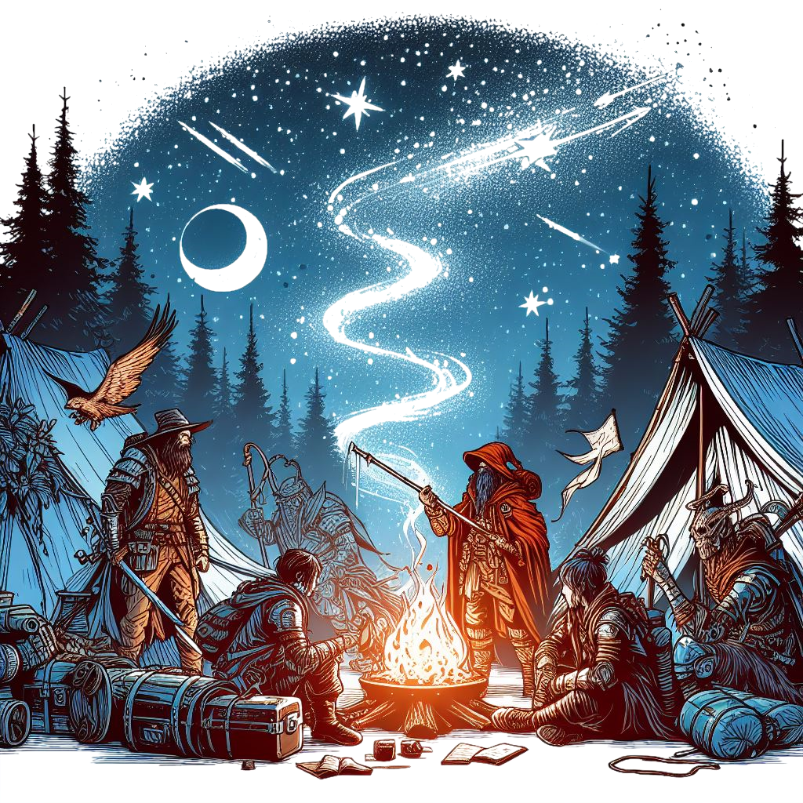Narrate a simple travel for an hour or so, then proceed to the **Druid’s Home** location.

## If players go to the druid right away…

Narrate a simple travel through the night.

The journey will take about 4 hours.

At a random hour in the night, ask the player(s) with the highest **Sense** for a **Sense** Check (sight). For at least 10, they notice a **Forest Smoke** about a kilometer away. If they investigate, proceed to the **Forest Smoke** random encounter (end of the book).

Nothing else happens.

# Riven House PuzzleE:\Work\GitHub\Call of Heroes Design\StarterAdventure\UI\Title Underline.pngTitle UnderlineRoad to Riven’s Home

Continue from here when the players start walking towards Riven’s home, no matter where they were previously.



*As Ser Alan guided you, the way through the forest*

*leads you deeper and deeper into the thicket.*

*Eventually, you come across a subtle path that,*

*which you guess leads directly to Riven’s house.*

*However, as you walk, the air gets foggier and*

*foggier with each step. Keeping an eye out for*

*danger, you notice something strange on a nearby*

*tree: a set of runes etched and burned into the bark.*

*[Show the players the rune]*

## Tree Runes Puzzle

The runes protect the surrounding of Riven’s house.

Whenever they try to continue walking towards the house, from any direction, they will end up back here, near the tree, as if they were walking in circles through the fog (reality-bending magic).

The **solution** is to write “VIII” at the top of the runes (each line’s sum is 22 in Roman numerals).

Once they write it, the fog dissipates and the road to Riven’s home is clear.

Here are some tips for you, the GM:

* *The tree is protected from being destroyed*
* *The fog does* ***not*** *clear on its own*
* *No matter which direction they come from, they will get back to the tree (they can leave if they want).*
* *If they leave, feel free to give some hints on the right as told by NPC’s in the town.*

Let players ask themselves for Checks and information. If they do, remind them that if they have Proficiency in something useful (e.g. Occultism, Arcana, Nature, etc), they get a bonus equal to their Level (which is probably 1).

If they ask for Checks, see the following:

On a **Sense Check** at least 10, they find some small pieces of charcoal on the ground near the tree.

On an **Intelligence Check** at least 10, players understand it’s a form of warding (protection) magic.

Hints (if players struggle too hard, you can give them a hint):

* *This is a puzzle*
* *They need to write something on the tree*
* *Notice that a symbol/rune is missing up top*

# E:\Work\GitHub\Call of Heroes Design\StarterAdventure\UI\Title Underline.pngTitle UnderlineRiven’s Home

After they clear the puzzle, continue from here:



*As the mist dissipates, the magical runes no longer*

*obscure the path ahead. After a few more minutes*

*of walking, you arrive at a small wooden hut.*

The players will likely investigate the hut.

There are no more traps. Riven is reluctant to show himself, but he will eventually walk out and check the noise.  
When he comes out, read this out loud:



*A tall figure emerges from the hut, moving slowly*

*and gracefully out of the door’s way and closing it*

*behind. It’s a fair-skinned elf, with a bald head*

*devoid of hair or beard. Clad in elegant yet simple*

*druidic attire, adorned with blush lips and eyes*

*subtly enhanced with eyeliner, he conveys an air of*

*mystique.*

*He studies you for a second, and, with a soft and*

*gentle voice, he speaks to you.*

*[Show the players a picture of Riven]*

## Riven Dialogue

Father Alan will engage in dialogue with the players while walking, to pass time. If they don’t engage,

feel free to directly say some of the **…** lines.



*“Yes?”*

*“You destroyed my warding spell. Have you any*

*idea how long those runes took to setup?”*

*“Who are you even? I told the townsfolk I’m busy*

*for a while! Obviously, busy trying to save myself*

*from being eaten alive by those ghosts roaming*

*about!”*

*“What do you want? If you want treatment for an*

*illness that’ll be 50 gold… no, 100 because you*

*ruined my protection spell.”*

See the next page for the rest of the dialogue.

## *Riven (Riven.png)*

**Base Suspicion**: 8

He is soft-spoken, gracious, sarcastic. Easily annoyed, but willing to help.

Here are some tips:

* *He is secretly working with Mortessa to keep citizens alive and slowly spread propaganda against Sedrik.*
* *He is secretly a hag; Mortessa gave him illusion magic to appear beautiful (Check at least 15 to detect)*



*…****Curse mark****? What are you talking about, let me*

*see… [Riven takes a look at the curse mark] Oh my!*

*What on earth is that… I can sense very powerful*

*black magic! I have heard rumors about this, but I*

*was not sure it is real… [keep reading out loud]*

*“This is a blood curse! Where did you get this?”*

*“I’m not messing with that! You got this from the*

*black ghosts? You know these things are drawn to*

*people with black magic artifacts, right?”*

*“I don’t even know how to cure that! It’s not a*

*normal curse! It’s like a tracking blood mark! Those*

*things could get here any moment!”*

*[After a while of debating, Riven will eventually*

*agree to help them]*

*“Fine… there… there might be a way… but it’s not*

*easy. And I’ll need a favor in return.*

*There were rumors of an item - a lamp - which,*

*instead of oil and oxygen, it consumed dark*

*energies. Rumor has it the old graveyard keeper*

*had a lamp like this, to protect himself from the*

*dark baggage of the dead, and draw trap in it any*

*dark energies to prevent the dead from rising.*

*However, he died years ago. That graveyard has*

*been unused for decades… because it really had*

*some black energies about, causing the dead to*

*sometimes not stay dead.”*

*“Bring me the lamp and we’ll try to fix that thing*

*on your body. The graveyard is an hour or so*

*North-West of Whispervale.”*

*“In return, I need you to help me recreate the*

*warding spell you broke. For that I will need you to*

*retrieve an item for me. There is a old mansion*

*near Whispervale. Its basement is magically locked.*

*Just say the password Farell and it will unlock.*

*From there, bring me a crystal sphere”*

*“Go now. I don’t want to waste any time. Neither*

*do yo.”*



*…****How do I know about the******sphere****? Cause you can*

*see it from the outside, through a crack in the wall,*

*if you look from the right angle. And I can tell how*

*magic works when I see it [partial lie].*

*…****My appearance****?*

*[Have players make a Check a.l. 15 to reveal it’s*

*illusion magic to make himself look pretty]*

*[If players don’t know it’s illusion magic] Please.*

*Don’t question my style choices.*

*[If they know] So you know… keep it a secret, will*

*you? I prefer people see me as beautiful on the*

*outside as I am on the inside.*

*…****My true form [Trust <5]?*** *No.*

*…****My true form [Trust 5]?*** *I am not an elf. I am*

*a hag. There, now you know. I want to help people.*

*But I can’t if they’re scared of me.*

*And no, you can’t see my true form.*

*…****Why I live alone here****? I like nature.*

*…****People in town****? I help them. Usually for gold, other*

*times just for information. I cured Boris the*

*blacksmith’s fever. He walks with a limp now, but his*

*life is saved. I’ll cure someone’s infection or*

*disenchantment every now and then.*

*…****Sedrik****? He used to live in the mansion. He was a*

*noble. Rumor has it he went mad and killed all his*

*staff [lie]. Nobody knows what happened with him*

*after that [lie].*

*…****Mortessa [Trust <4]?*** *Never heard that name.*

*…****Mortessa? [Trust 4]?*** *She was Sedrik’s fiance. It is*

*said she is still alive, somehow…*

*…****Mortessa [Trust 5]?*** *She is the one who helped me*

*with this magic I am using. She merely asked that I*

*help her out with errands and I protect the townsfolk.*

*And I grew to like the town’s people…*

*[Trust 6+] A long time ago, I accidentally ate some*

*people in town. I regret it now. Truly, I do.*

*Mortessa offered me this form, and in return, I was to*

*‘keep the people alive’ and give her some information*

*every now and then, through a raven. That’s all it is.*

*I don’t know how she is still alive, and I don’t care.*

*I don’t question it. The attack you received - not hers.*

*…****Black bead****? Show me… leave it here. I will take a*

*look if you want while you’re away.*

# E:\Work\GitHub\Call of Heroes Design\StarterAdventure\UI\Title Underline.pngTitle UnderlineWhispervale

*After a good while of traveling, you spot a wooden*

*sign, marking your approach to Whispervale.*

*As you journey onward, you see smoke rising in the*

*distance. [Show players a picture of Whispervale]*

*[If day] Not long after, you start seeing people on*

*the outskirts of own, eyeing you either with*

*suspicion or indifference.*

*You’re passing by houses of stone and wood with*

*brown roofs, emanating the comforting scents of*

*freshly cooked food and pine trees. Not far from the*

*town center, you spot a church - old, but well-*

*preserved.*

*As you look into the very distance, you see the*

*vague shape of a large mansion cloaked in*

*shrubbery. Perhaps it is abandoned.*

*Ser Alan spots the church, and speaks without*

*hesitation:*

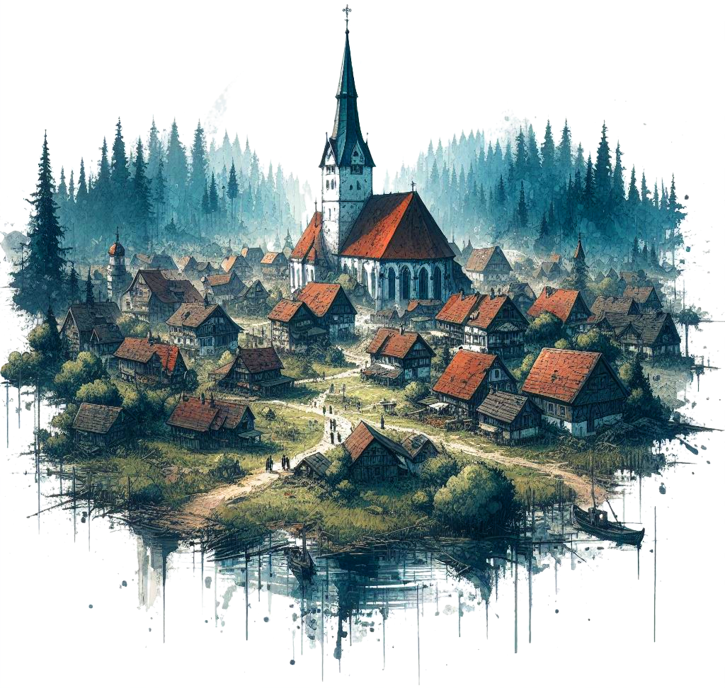*“I will be headed that way. The town should be safe.*

*Give me a few minutes to unpack my travel supplies*

*and come to the church whenever you have the*

*time to collect your reward. You’re always welcome*

*there, whether you need healing or guidance.”*



*[As GM] Ser Alan will now be able to heal someone for*

*1d8 once per Quest, for a fee of 50 gold. Whenever you*

*complete a Quest, his healing ability is usable again.*

*“You should have some rest. The Drunk Drake has*

*good rooms and food.”*

*[If they don’t have the Whispervale map] “By the way,*

*I think you should have this.” [give the players the*

*Whispervale Town Map]*

## Quest Complete!

Quest complete! Everyone

regains all Health and resources!

## Town Locations

Players can go to any of the following locations of interest, each with a respective important NPC:

* *Drunk Drake Tavern (Chug the Innkeeper)*
* *Town Square (Sylvaine the Bard)*
* *Blacksmith (Boris the Blacksmith)*
* *Marketplace (Periwinkle the Merchant)*
* *Church (Ser Alan)*
* *Mansion (Sedrik)*

# E:\Work\GitHub\Call of Heroes Design\StarterAdventure\UI\Title Underline.pngTitle UnderlineDrunk Drake Tavern

*You step into the Drunk Drake Tavern, a cozy inn*

*filled with the scent of mead and a lingering aroma*

*of stale venison. The wooden walls are adorned with*

*proud trophies of past hunts: deer heads and antlers*

*graze down at the 3 villagers drinking their sorrows,*

*each at a different table. As your eyes wander, they*

*are drawn to the sight of a massive bronze claymore*

*hanging neatly on the tavern’s right wall.*

*However, as you look to the left, something else*

*catches your attention even more. In front of the*

*worn counter, a curious creature casts a humongous*

*shadow - an orange dragonborn, so large that he*

*might as well cover half of the tavern’s width. He is*

*filling a mug with frothy beer while simultaneously*

*tending to the tavern’s cleanliness, his enormous*

*tail sweeping the floor with a wet cloth.*

*[Show the players a picture of Chug]*

*“Huh?” you hear his deep*

*voice say as he turns. “Bite*

*my tail and call me lizard!*

*We have new clients!”*

*says the dragonborn*

*happily. “How may I serve*

*you, friends?”*

## *Chug (Chug the Innkeeper.png)*

**Base Suspicion**: 10

His full name is Ogcharug Brightscale. Very friendly to friends. Can turn very serious and angry with hostile people. Very talkative.

Here are some tips:

* *He used to be warrior, but he likes eating and drinking so much that he became an innkeeper.*
* *His old sword still on the wall - he will only give it to them if they reach 0 Suspicion through roleplay.*
* *Speaks Draconic (and Common)*



*”What can I serve you with? Food? Rooms? Ale?”*

*“We have some fine venison and we bake solid bread!*

*I mean… solid as in good… it’s good bread.”*

*”What are you doing in Whispervale!? Don’t you know*

*the roads are dangerous!?”*

*“We haven’t had a lot of patrons since the* ***shades*** *and*

*the* ***goblins*** *have been haunting the roads. Just these*

*few folks here who come every day. We used to have*

*more back in the day, but not even merchants are*

*coming now!”*

*“Those black* ***shades****, as we call them, have been flying*

*about, chasing people and such. Been happening for a*

*few weeks! Just 3 days ago they attacked a fisherman*

*and a couple of guards on duty on the outskirts! Fish*

*boy died of a strange mark... one of the guards is gone…*

*and our* ***priest is missing****, too!!! I don’t know what on*

*earth is happening to our town, but it’s bad!”*

*“My waiter Keisha is gone too! Blasts! If you ever find anyone, let me know! I heard there are more people*

*missing.” [true, random villagers, farmers, etc missing]”*

## If players have Felinar…

If players have the Felinar of Passing, they notice a hooded figure standing at one of the tables

TODO



***...Curse Mark****? Good gravy! That looks horrific!*

*You got that from the shades? It’s the same as the*

*fisherman’s! I don’t know much about curses. Maybe*

*Riven, the druid in the forest does… or maybe our*

*priest… well, if he’s still alive that is. Hope it’s not too*

*bad, though!”*

***…Missing priest****? Haven’t seen him in weeks! His*

*apprentice - also gone! He was acting strange, both of*

*them were, I tell you. Ending sermons early, not wanting*

*to talk to people, rejecting healing, all that.*

*There’s something fishy happening at the church,*

*mark my word and bite my tongue!*

***…Goblins****? Yeah! Screw those guys! Usually nothing a*

*few guards and a dog can’t take. But lately they seem*

*more organized! They’re stealing everything! Periwinkle*

*[the merchant] is furious! Surely he’ll give you good coin*

*if you bring back stolen stuff!*

***…Periwinkle****? Short, big ears, long black snoot. Sells all*

*sorts of junk. You’ll find him in the marketplace. [it’s a*

*raccoon Bertle]*

***…Riven the druid****? Riven cures minor diseases and weak*

*disenchantments. Appeared out of nowhere some years*

*ago and here she is. Never met her. Druids give me a*

*wicked feeling in the stomach.*

***…Sylavaine the bard****? She comes often. And goes often.*

*And drinks just as often. When she’s not a nuisance,*

*I don’t mind her. I have a feeling she has sticky fingers if*

*you know what I mean…*

***…Boris****? He’s just downtown, smithing stuff. Dunno…*

***…Mayor Thumbson****? Not much mayor work done around*

*if you ask me. He keeps track properties, archives, etc.*

***…Missing children?*** *Not sure any are missing now… there were some strange incidents a few years ago… 3 children disappeared in the span of a few months. Maybe it was goblins, maybe wolves, maybe something else… [with spooky voice] A HAG! Hahaha… [is amused]*









# Title Gradient 6Introduction

Use this template for homebrew. It is similar to what the final version of the book will look like.

You’re free to edit and adjust it to your liking.

You have all the specifications in the README file.

The font used is LinuxLibertine (you will have to install it on your computer).

Select this text together with the chapter section, copy it and paste it.

The underline should be 5 pixels below the ‘p’ immediately after the graphic goes below the chapter section.

The Chapter Section should always be on the left.

Always use copy paste for these elements to preserve the format.

## Subsection

This is a subsection. No special rules.

## Background & Details

After you’re done with a page, you can copy and paste the gradient from the top and bottom of the page.

## Title Text

For a main title (like QuestGuard), use the PSD template on <https://photopea.com> (or Photoshop) to create your title. Create a new text based on the specifications with the text tool, then overlay letters one by one over your font letters. Then delete the text and keep only the overlapped letters.

Oh yeah, and you need to load the Eczar font into Photoshop.

## Readme

For the specifications of the font, document, etc, see the README file.

Chapter Section

This is an alternative look for the Chapter Section.

## Supsection

This is another example of a subsection with some normal text, and following it is an aside box.

You can use this for **read-aloud text**.

*Here we have a nice little aside box. Use*

*Calibri* ***Italics 10.5px*** *when working with this.*

*By the way [this is not meant to be read aloud].*

*Also, leave 1 space of indentation to the left.*

*And make sure there is enough space on the right.*

*This text is just a continuation of the text*

*above, in a different font.*

Feel free to resize the aside box background as you see fit. Also, here is a list, also Calibri I. 10.5px:

* *Small lamp*
* *25 gold in leatherworking materials*
* *Shortsword*

That was a list. Use copy/paste to paste the list.

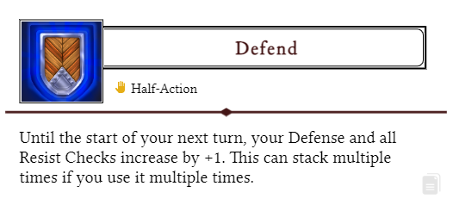

That was an Ability from the website (using the copy/paste button from the Ability box).

## Artwork

This text works

great with the goblin

on the right side of the

screen and the artwork

fits well. Lorem ipsum

dolor sit amet tristique

delirium sumus but take

into consideration that

the text should be

just long enough to fit here

nicely. The easiest way to

add artwork like this is to just

set its box to “behind text” and

you will be able to move

it around without doing

anything wicked to the

text, and gives you full control of

how you position your text. Use

spaces and enter with courage,

lads!

## Tables

Copy and paste this table when you want to create one. Pretty simple.

|  |  |  |
| --- | --- | --- |
| **Dice Roll** | **Description** | **Effect** |
| 1 | Stun | Target skips its next turn |
| 2 | Slow | Target has -2 Movements |
| 3 | Charm | Still not sure to this day |
| 4 | Exhausted | Half movement & actions |
| 5 | Fumbling | -2 to all rolls |
| 6 | Dazed | Halved actions, sir! |

That was a table. The background gradient is just an image, good luck moving it. If your table is on the left, you might want to flip the gradient for the rows.

